|  |  |  |  |  |
| --- | --- | --- | --- | --- |
| Version | Date | Document Status | Author | Role |
| V0.1 | 28.11.2016 | Initial draft | Majid Ahmed | SAP C4C Consultant |
| V0.2 | 30.11.2016 | Initial draft | Majid Ahmed | SAP C4C Consultant |
| V0.3 | 06.12.2016 | Initial draft | Verity Travers | SAP C4C Consultant |
| V0.4 | 12.12.2016 | Update post Megger review | Verity Travers | SAP C4C Consultant |

**Index:**

1 Document Purpose 3

2 Functional Description (Business Purpose) 3

2.01 Purchase Order Number 3

2.02 Currency 3

2.03 Order Processor 4

2.04 Header Text 4

2.05 Sub Items 4

2.06 Material Number 4

2.12 Material Item Texts 5

2.07 Options / Alternatives 5

2.08 Translations 5

2.09 Footer Text 6

2.10 ERP Quotation Price Controls 6

2.11 Bank Details 6

2.13 Column Structure on the Quotes Form 7

2.14 Water Products Logo 7

2.15 Chapters In Sales Quote 7

3 Functional Design 7

3.01 Your Enquiry (Purchase Order Number) 7

3.02 Currency 8

3.03 Order Processing Employee 8

3.04 Header Text 8

3.05 Sub Items ( Bill of Material Explosion ) 8

3.06 Material Number 9

2.16 Material Item Texts 9

3.07 Options and Alternatives 11

3.08 Translations 11

3.09 Footer Text 12

3.10 ERP Quotation Price Controls 13

3.11 Bank Details 14

3.12 Sales Quote Form – Column Structure 14

3.13 Water Products Logo 15

3.14 Sales Quote Chapters/Headings 15

4.0 Authorisations 16

4.1 Reasons for request 16

4.2 Boundary and Framework Conditions 16

4.3 Risks 16

4.4 Legal Requirements / Compliance 16

5 Technical 16

5.1 Objects used 16

5.1.1 Technical Design description 16

# Document Purpose

The purpose of this document is to provide an explanation of the enhancements required to the standard C4C sales quote output document to support the business requirements detailed in the blueprinting discussions with the Megger Group.

# Functional Description (Business Purpose)

Once a quotation has been created, it can then be output as a quotation document which can be shared with the customer via email, fax or as a printout. The quotation document as created by the solution in terms of structure and content, meets most of the Megger Groups needs. There are, however, several business requirements that the standard functionality will not meet, and as such enhancements are required to the output sales quote document.

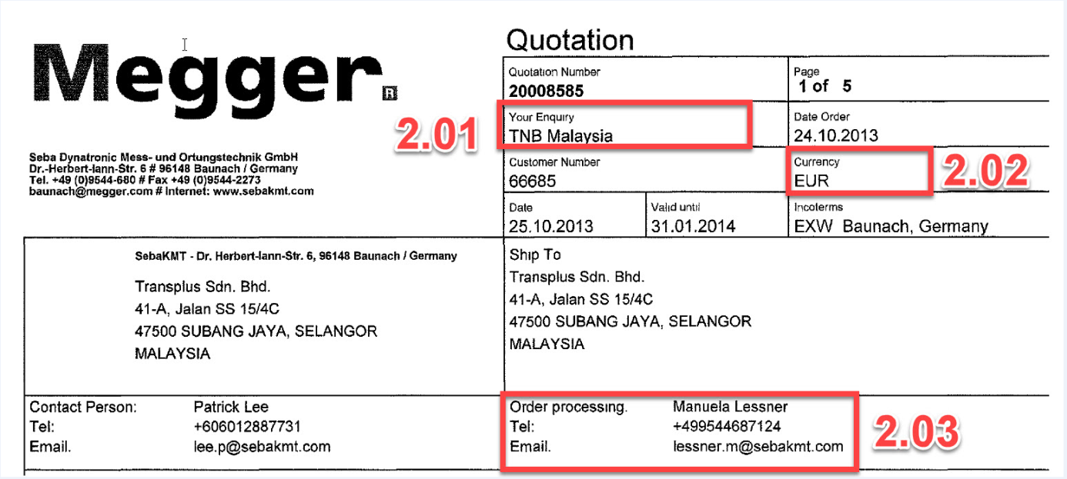

## Purchase Order Number

The first requirement is that the header area of the quotation should show ‘Your Enquiry’ representing the customers reference to the quotation. In C4C this maps to the ‘External Reference’ field (the equivalent PO number field). This field together with any value present in this field will be copied to the sales quote document.

## Currency

Megger have a requirement that the quotation currency i.e. the default currency for the customer as per their sales area data be shown in the header area of the document. Whilst the document currency is shown against the Net Price, Net Value of each line item and the Total Values within the C4C document, standard functionality does not allow document currency to be maintained in the header area. This currency field is available in the sales quote and will be made available in the sales quote document.

## Order Processor

On the existing ERP quotation the Order Processor represents the inside sales person involved in the sales quote. The person who is displayed on the form is the person who has created / raised the sales quotation. A new party role ‘Order Processor’ will be configured and made available to the Sales Quotation. The order processor will default to be the user who created the sales quotation in the C4C system. The user can manually change this employee, if required. The form will retreive the following information from their C4C employee record:

* First Name & Last Name
* Telephone Number
* Email address

## Header Text

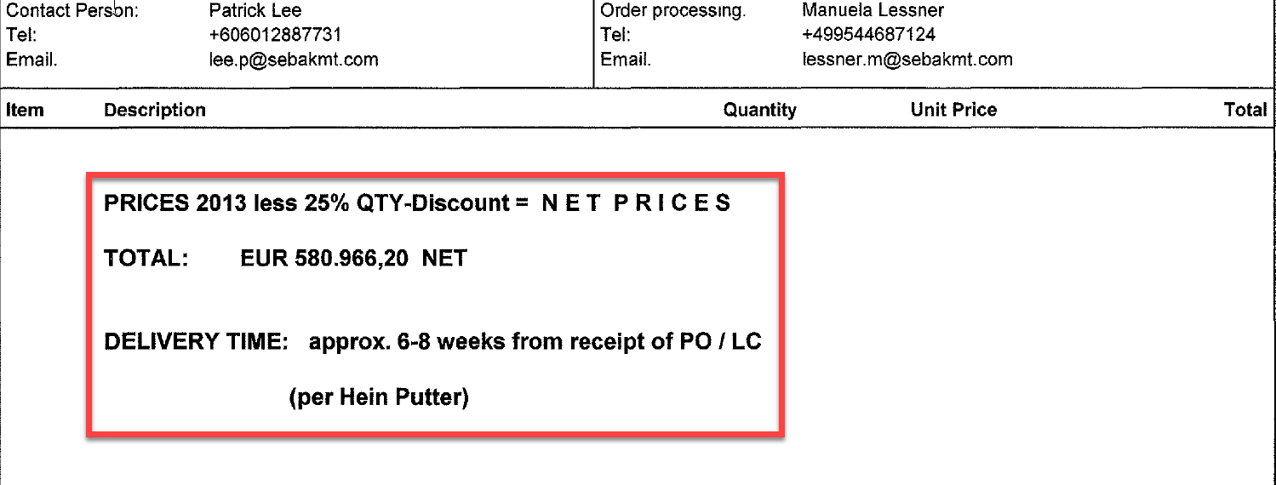

The sales representative manually enters text into the sales quote. This text is then available in the sales quote document directly below the sales quote header for the customer to read. As standard the manually entered text appears at the end of the sales quote. The sales quote document will be adapted so that this text appears below the sales quote header information.

Datum Preisliste needed

## Sub Items

The Megger group sell some products which have several constituent components. These constituent components are shown on the Megger quotation document as sub items of the main item. An example of such a product is a Sales Kit where the main item is listed as a positive number and sub items are listed below as minus increments of 10 eg. -10, -20 and so on.

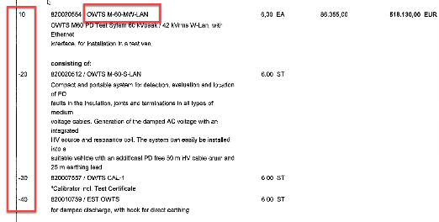 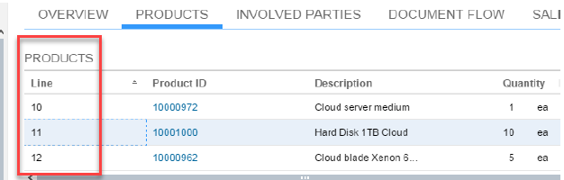

## Material Number

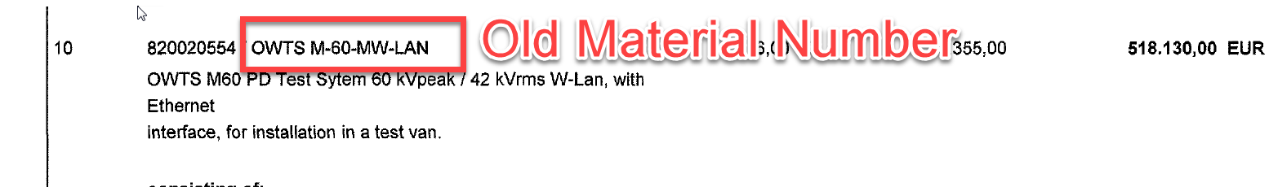

There is a requirement from Megger that an old material number is also shown beside the current ERP material number in the sales quote document. As the old material numbers are not currently maintained in C4C, the solution will be adapted to incorporate the old material number within the sales quote and then this will be made available to the sales quote document.

## Material Item Texts

Beneath the ERP Material ID / Old Material Number there is a requirement to present the product description / texts that are associated with the material. These descriptions / texts are maintained in ERP against the material master record and subsequently replicated to C4C.

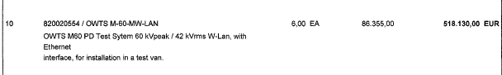

The form must display the sales text in the language of the customer. To support this, the texts must be maintained in the relevant language against the ERP material master record. The form should search for available texts. The priority of the texts that should be displayed are as follows:

* Sales text
* Basic data text
* Short description

## Options / Alternatives

There is a requirement from Megger for the quotation document to show the options and alternative products associated with the selected main item. To meet Megger’s requirements these options / alternative items will be manually added to the sales quote. The user will select whether the product entered is an option or alternative by changing the item type. Below is an example:

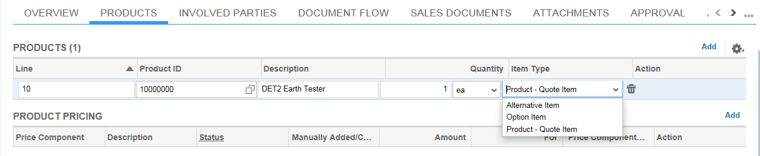

## Translations

The Megger sales quote document is sent to the customer in the language that is stored against the account. Whilst the language of sales quote document is based on the language of the sales organisation or sales office, a customer can receive a sales quote document in the preferred language that is specified in his customer record. The preferred languages being deployed are French, German, Swedish and English.

## Footer Text

The standard Megger sales quote document shows the payment terms and the shipping terms on the first page and these are then repeated on the footer of every subsequent page. The footer also includes information (standard text) on the sales organisation responsible for the sales quote. This footer text will be displayed on all sales quotation documents.

The final page of the quote form will display the general terms and conditions:

Germany (English)

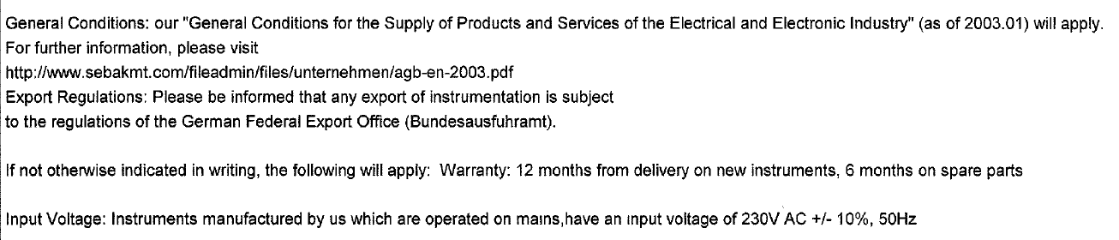

Sweden

|  |  |
| --- | --- |
| C*onditions of supply:* | See EL98 (attached hereto) |

## ERP Quotation Price Controls

Megger use the POtyp field (VBKD/BSARK) to control the output of prices. The values maintained in this field control how the prices appear in the sales quote document. The values below show which prices are output. As standard, all prices related to an item are shown within the sales quote form. Logic will be created to enable this functionality within the C4C sales quote form.

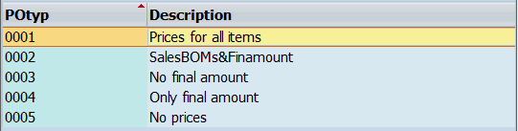

## 2.11 Bank Details

Each of Megger’s sales quote forms maintain payment bank details which are specific to the sales organisation (country). Germany will have a different bank and associated paying in account than Sweden and the other countries in the Megger Group. The template forms are to be adapted so that payment details are maintained which are specific to each sales organisation.

## Column Structure on the Quotes Form

The values maintained within the Megger sales quote form are separated by columns. The structure of the standard sales quote form within the C4C solution is different. The structure and position of the fields to be maintained on the C4C sales quote for for all sales organisations / markets is as as follows:

* Item Number
* Quantity
* Description
* Price
* Amount

Below is an example of how the sales form column structure will appear. The currency code displayed will change depending on the currency stored in the quotation.

|  |  |  |  |  |  |
| --- | --- | --- | --- | --- | --- |
| ***Pos.*** | ***Qty.*** | ***Art. No.*** | ***Description*** | ***Price SEK / ea*** | ***Amount SEK*** |

For example, Sweden Market sales form columns

## Water Products Logo

There is a requirement that there should be a specific sale quote form for water products. The standard sales quote form applies to all products within a quote. A separate Water Products quote will be created and rules will need to be created to have this separate quote form automatically determined.

## Chapters In Sales Quote

Megger users make chapters in the quotation which are used to control grouping of products and sorting e.g. *****Optional*****. In order to do this, Megger maintain a text item category “YGTX” against their ERP quotation which is used in the sales quote to create the chapters to allow products to be grouped. To achieve this requirement an text item type will be created in C4C. The form will be adapted to not display the item number for a text line.

# Functional Design

## 3.01 Your Enquiry (Purchase Order Number)

Megger have a requirement to capture the customers reference / purchase order numbers on the C4C quote. This field is currently maintained on Megger sales quote output forms as the “Your Enquiry” field within the header area of the sales quote. To meet this requirement the “External Reference” field which is available within the sales quote header of C4C will be used to record purchase order values. The description of the field on the standard form is ‘Your Reference’. This will be renamed to “Your Enquiry” as per the label on the current Megger ERP Sales Quotation form.

## 3.02 Currency

The “currency” field is a standard field within the sales quote header, however, this field is not available to the sales quote document. The standard C4C sales quotes displays the currency against the item and total price lines.

In order to meet Megger’s requirement that the customer should be able to see the document currency, this field will be made visible on the sales quote document. This field must be extended using SDK to make it available to the Output Form Template. Once this currency field has been extended to the form template it will then be added to the sales quote form.

## 3.03 Order Processing Employee

On the existing ERP quotation the Order Processor represents the person at the sales office who is involved in the sales quote. The person who is displayed on the form is the person who has created / raised the sales quotation. A new party role ‘Order Processor’ will be configured and made available to the Sales Quotation. The order processor will default to be the user who created the sales quotation in the C4C system. The user can manually change this, if required. The form will retreive the following information from their C4C employee record:

* First Name & Last Name
* Telephone Number
* Email address

## 3.04 Header Text

The header text allows the sales quote creater to add free text such as a reminder of payment terms, future discounts, promotions or other customer relevant information. This header text on the Megger output document is positioned just below the header area. On the C4C quote document, this text appears at the bottom of the final page of the quote. To ensure consistency between the two forms and to meet Meggers requirements, this Header Text will be repositioned below the Header area of the C4C quote document.

## 3.05 Sub Items ( Bill of Material Explosion )

There is a Megger requirement that any material that is the main item and has sub items as part of it, then these sub items must also be displayed below the main item. A typical example of such a product is a Megger Sales Kit. This functionality is supported so that if a quoted product has a relevant Bill of Material (BOM), then when the “Request Pricing” call is made, the items will be shown as sub items in the product list within the quote.

For the sub items to be displayed properly, these sub item products must also be maintained in C4C within the same sales organisation and distribution channel of the sales quote document. All sub items related to main items must be loaded from the ERP system into C4C.

 

The line item increments in C4C will be different to those maintained in ERP.

## 3.06 Material Number

The Megger sales quote document currently shows the old material number as well as the current ERP material number within the sales quote document. The requirement from Megger is as follows:

* Display the product external ID (ERP material number)
* Display the old material number

In order to achieve the display of the old material number, a new field will be created against theC4C product with the field name “ Old Material Number”. This field will then be extended for use with the web service for material master replication from ERP. The WSDL file will be downloaded from the communication arrangement “Product Replication with Sales data from external System”. This WSDL file will then be uploaded into the HCI integration scenario for product replication. The “Old Material Number” field that then becomes available is then mapped to MARA / BISMT field in the ERP materials Idoc. This will enable the values maintained in ERP to flow to C4C and where available old material number fields will be automatically populated during a data load.

The “old material number” number field will also be extended for use with the quotes form template and this will allow its usage and visibility on the sales quote output document.

## Material Item Texts

Beneath the ERP Material ID / Old Material Number there is a requirement to present the product description / texts that are associated with the material.



The form must display the sales text in the language of the customer. To support this, the texts must be maintained in the relevant language against the ERP material master record. No additional logic is required in the form to support this. These texts are transferred into C4C product master record as part of the ERP <> C4C integration.

The form should search for available texts. The priority of the texts that should be displayed are as follows:

* Basic data text
* Sales text
* Short description

Below is a screenshot of the **sales text** from the ERP Material Master record:

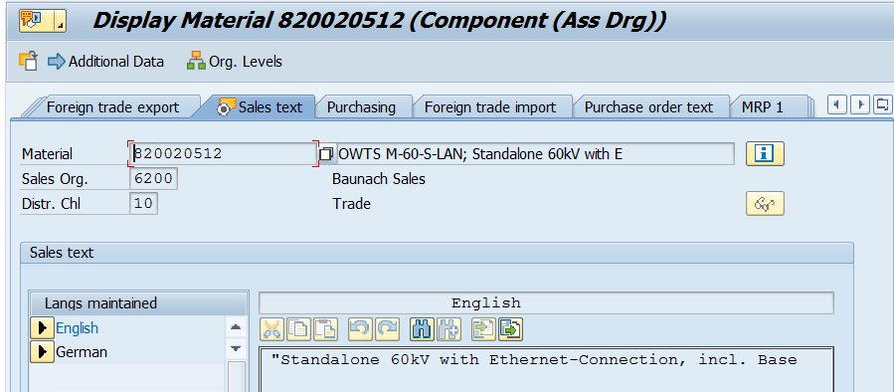

Below is a screenshot of the **Basic data text** from ERP Material Master record:

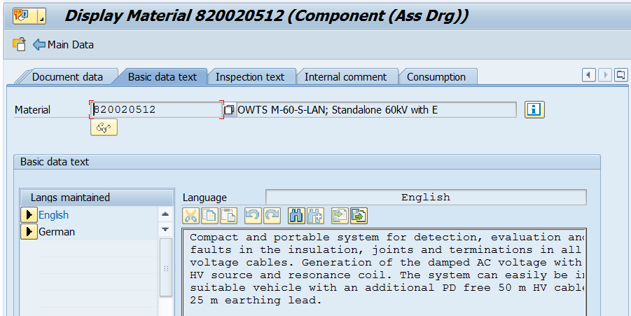

Below is a screenshot of the **short description** from the ERP Material Master record:

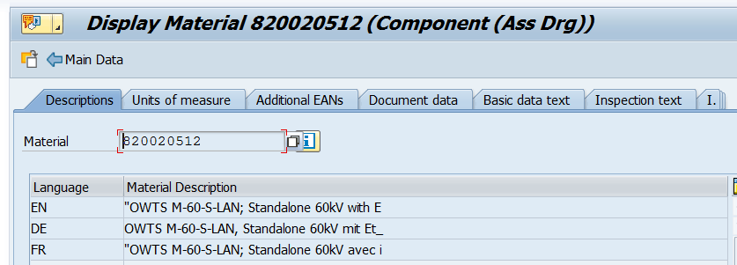

## 3.07 Options and Alternatives

To support Meggers business processes, alternative / option items will be made visible on the sales quote form. These alternative / option products are similar to the offered products and by displaying the quoted products together the customer can then choose between them. To achieve this functionality in C4C, users will manually add the alternative / optional products onto the quotation and then manually change the item category to represent the products as either an option or an alternative. The two item categories that are configured in the Megger ERP system will be created in C4C:

* ZOPT - Option Item
* ZALT - Alternative Item



These item categories will be relevant for pricing so a unit price can be displayed to the customer. However, the items will be considered as ‘Free Goods’ where a 100% discount is automatically assigned and subsequently the value of the item does not impact the overall net value of the sales quotation. The option / alternative items will be presented on the form.

## 3.08 Translations

The sales quotation document will be available in the following languages; English, Sweden, French and German. Although the sales quote form will be assigned to the Megger sales organisations in the languages of those sales organisations, there is a requirement to be able to send a quotation document to a customer based on the language preference maintained against each customer within the Megger customer master. To support this the language will be maintained against the account.

## 3.09 Footer Text

The standard Megger sales quote document shows the payment terms and the shipping terms on the first page and these are then repeated on the footer of every subsequent page together with the details of the sales organisation. To meet this requirement the sales quote form will be adapted to make the footer static on every page. The Payment Terms and Shipping Terms are standard fields available on the standard quotation form. The company information will be a standard text. The text displayed will vary depending on the sales organisation raising the quotation. The mapping is in the table below.

Below is a screenshot of the current information displayed for Banauch (Sales Organisation 6200).

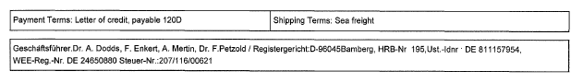

Payment terms and shipping terms will vary depending on what has been agreed for the sales quotation. The company information text will vary depending on the sales Organisation:

|  |  |
| --- | --- |
| **Sales Organisation** | **Company Information** |
| 6000: Sweden Sales | No footer text is required for Sweden |
| 6200: Banauch Sales | As per screenshot above |
| 8700: Germany Sales | Megger GmbH   Obere Zeil    2     D-61440   Oberursel      Deutschland    Ust-ID   Nr.:   DE 266481704 T: 06171 – 92987-0  F: 06171 – 92987-19  E:deinfo@megger.com W:www.megger.com/de |

The final page of the quote form will also be adapted to include a static text as below concerning the delivery terms.

A German sales quotation can be identified by the Sales Organisation 6200 and 8700. The following text will be displayed for Germany:

English:

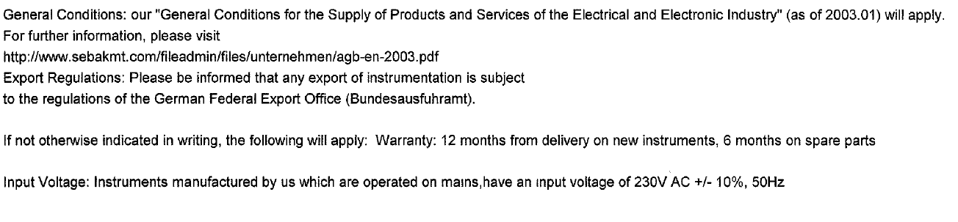

German:

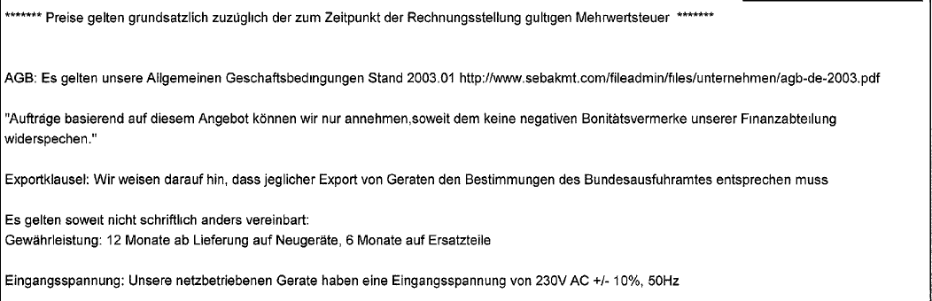

A Swedish sales quotation can be identified by the Sales Organisation ‘6000’ which will be captured in the sales quotation. The following text will be displayed:

|  |  |  |  |  |
| --- | --- | --- | --- | --- |
| C*onditions of supply:* | | | See EL98 (attached hereto) | |
|  | | | |  |
|  |  |  |  | |
|  |  |  |  |  |
|  |  |  |  |  |

## 3.10 ERP Quotation Price Controls

Megger use the ERP ‘POtyp’ field (VBKD/BSARK) to control the output of prices. The values maintained in this field control how the prices appear in the sales quote document. The values below show which prices are output:

|  |  |
| --- | --- |
| **POtyp Field** | **Output Requirements** |
| 0001 | Output all prices and the total amount (it’s the default) |
| 0003 | Output all item line prices and supress the output of total amount |
| 0004 | Supress output of item line prices and only output the total amount |
| 0005 | Completely supress output of all prices and total amount |

This functional specification will create logic into the sales quote pricing process to replicate the ERP pricing output rules to control which prices should be shown in the quote. A new field is required to capture the different output options. This will be manually updated by the user. The default value will be set to 0001.

There is a general rule across all options that if the item category is YABH suppress the the unit price and total for each sub item. Where item catgory is YABI, the unit price has to be outputted for for all sub items and the header. The header should be the total of all the dependent sub item lines. To support this, specific item categoires will need to be present in the sales quotation. By maintaining equivalent item categories the rules that have been applied in the ERP sales quotation form can be introduced into the C4C sales quotation document.

Note: option ‘0002’ is no longer required and has been removed an an option based on the general rule above regarding YABH and YABI item categories.

## 3.11 Bank Details

The Megger sales quote document shows Megger’s bank details which are used by customers for payment of their invoices. These details are different for each Megger country and are specific to the sales organisation from which the sales quote has been generated.

The bank details will be added to the final page of the sales quote form, directly above the footer of that page. The bank details will be a static text as its envisaged that these will not be subject to constant change. The bank details displayed will be determined based on the sales organisation of the sales quotation. No language dependent bank details have been identified. The same text will be displayed for all languages.

|  |  |
| --- | --- |
| **Sales Organisation** | **Bank Details** |
| 6000: Sweden Sales | Bank: Danske Bank Sweden  SWIFT: DABASESX  Account No: 12410106552  Bank giro: 366-0313  Postgiro: 92 75 13-2  IBAN: SE96120000000124101065 |
| 6200: Banauch Sales | BANK ACCOUNT (EUR):  …Commerzbank AG, Bamberg, Germany  IBAN: DE73 7704 0080 0124 6040 00  SWIFT: COBADEFF770  BANK ACCOUNT (US$):  …Commerzbank AG, Bamberg, Germany  IBAN: DE46 7704 0080 0124 6040 01  SWIFT: COBADEFF770 |
| 8700: Germany Sales | Bank: Commerzbank AG  BLZ: 500 400 00  BIC/SWIFT Code: COBADEFFXXX  IBAN: DE18 5004 0000 0582 4339 0 0  KONTO: 582 433900 |

## 3.12 Sales Quote Form – Column Structure

The column structure within the standard form will need to be adapted to meet Megger’s market requirements. The column structure has been defined as follows:

* Item Number
* Quantity
* Description
* Price
* Amount

Below is an example of how the sales form column structure will appear. The currency code displayed will change depending on the currency stored in the quotation.

|  |  |  |  |  |  |
| --- | --- | --- | --- | --- | --- |
| ***Pos.*** | ***Qty.*** | ***Art. No.*** | ***Description*** | ***Price SEK / ea*** | ***Amount SEK*** |

Sales Form Column Structure

## 3.13 Water Products Logo

As per the Megger requirements a separate sales quote form will be created which is specific to Water products. This form will have all the attributes of the standard Megger quote form with the only difference being the logo as below:



This quote form will only be available to sales office ‘SO_24 Water Sales’. When a sales quote is created for this sales office then the Water Sales quote form will be automatically determined. This will be achieved by creating a template selection rule specific to water products. The rule will consist of the sales unit SO_24 and the “Water Sales Quote Form”. Sales Office is not available as a selection parameter in the form determination. A new field will be created which copies the value maintained in the sales office field. This will not be visible or changeable to the users. Once the field created it will be available as an available field in the form selection table.

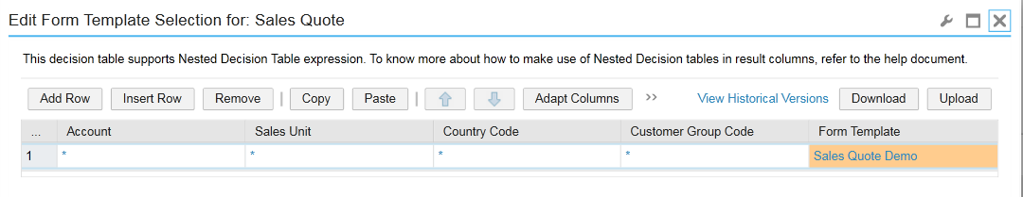

## 3.14 Sales Quote Chapters/Headings

Megger use chapters in their sales quote to sort and group products. This functionality is achieved through the usage of a text item category “YGTX” in their ERP system. To create these chapters in the C4C sales quote, an item category “ZGTX” will be created and assigned to the C4C quotation item type “AGTX” as below.

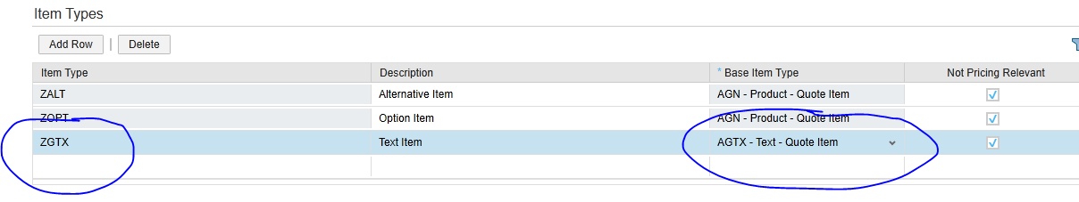

When the user maintains a description when adding a new line to the sales quotation C4C will determine the item type as a text item, however this text item option can also be manually maintained from the quote line item if required. To create the next grouping of products, the user will then add the next text line to create the next “chapter” after which the user will add the corresponding products. The form will print out line items in the sequence they are entered onto the sales quotation. No additional sorting or grouping rules are required.

## 4.0 Authorisations

There are no object specific, or business specific authorisation requirements.

## 4.1 Reasons for request

Standard configuration does not meet the business requirement.

## 4.2 Boundary and Framework Conditions

## 4.3 Risks

Not applicable.

## 4.4 Legal Requirements / Compliance

Not applicable.

# Technical

To be completed by technical resource assigned to the Megger Project.

## Objects used

### Technical Design description